Q 2
(1) How many types of polysaccharides you know?
There are many different types of polysaccharides, but some of the most common include:
- Starch: A complex carbohydrate found in plants, used as a storage form of energy.
- Glycogen: A complex carbohydrate found in animals, also used as a storage form of energy.
- Cellulose: A structural polysaccharide found in plant cell walls.
- Chitin: A structural polysaccharide found in the exoskeletons of arthropods and the cell walls of fungi. ¹

(2) Give examples of fighless birds
Flightless birds are birds that cannot fly. Some examples of flightless birds include:
- Penguins: These birds have wings adapted for swimming and cannot fly.
- Ostriches: The largest living birds, ostriches have wings but cannot use them for flight.
- Kiwis: These flightless birds are native to New Zealand.
- Rheas: These flightless birds are found in South America.
(3) Define: Taxonomy?
Taxonomy is the science of classifying organisms. It involves naming, describing, and classifying organisms into groups based on their shared characteristics.
(4) Write examples of Rhodophyceae.
Rhodophyceae, also known as red algae, are a group of algae that are characterized by their red color. Some examples of Rhodophyceae include:
- Irish moss: Used in food and as a source of agar.
- Dulse: A red seaweed that is eaten in some parts of the world.
- Carrageenan: A polysaccharide extracted from red algae, used as a food additive.
(5) What is Homologous chromosomes?
Homologous chromosomes are pairs of chromosomes that have the same genes in the same order. One chromosome in the pair is inherited from the mother, and the other is inherited from the father.
(6) What is cojoint – collatsed vascular bundle?
A cojoint-collateral vascular bundle is a type of vascular bundle in which the xylem and phloem are located side by side, with the xylem on the inside and the phloem on the outside. This type of vascular bundle is found in some dicotyledonous plants.
(7) What is Amitosis?
Amitosis is a type of cell division that does not involve the formation of a mitotic spindle. It is a simple process in which the cell nucleus divides directly into two daughter nuclei. Amitosis is most common in prokaryotes and some simple eukaryotes.
Section B
Q.3. Describe the concept of metabolic pool.
The metabolic pool is a collection of all the metabolites present in a cell at a given time. These metabolites are constantly being synthesized and broken down in various metabolic pathways. The pool is dynamic, with metabolites continuously entering and leaving. It allows for the efficient utilization of resources and the coordination of different metabolic processes.
Q.4. Draw well labelled diagram at T.S. of monocot root.
Unfortunately, I cannot draw diagrams directly here. However, I can describe the key features of a transverse section (T.S.) of a monocot root and provide resources where you can find detailed diagrams:
- Epidermis: The outermost layer of cells, usually single-layered.
- Cortex: A thick layer of parenchyma cells below the epidermis.
- Endodermis: A single layer of cells surrounding the vascular tissue, with Casparian strips.
- Pericycle: A layer of cells between the endodermis and the vascular tissue.
- Vascular tissue: Consists of xylem and phloem arranged in separate bundles.
- Pith: The central region of the root, made up of parenchyma cells.
You can find detailed diagrams of monocot root T.S. by searching online resources like Google Images or textbooks on plant anatomy.
Q.5. Write about collenchyma.
Collenchyma is a type of simple plant tissue that provides mechanical support to young stems and leaves. It is composed of elongated cells with thickened cell walls, primarily due to the deposition of cellulose. Collenchyma cells are living and often contain chloroplasts, allowing them to contribute to photosynthesis.
Q.6. Importance of botanical garden.
Botanical gardens play a crucial role in plant conservation, education, and research. Some of their key importance includes:
- Plant conservation: They preserve endangered plant species and their genetic diversity.
- Education: They provide opportunities for learning about plants, their ecology, and their importance to humans and the environment.
- Research: They serve as living laboratories for botanical research, contributing to our understanding of plant biology and evolution.
- Horticulture: They showcase a wide variety of plants, including ornamental, medicinal, and economic plants, promoting horticultural practices.
- Public awareness: They educate the public about the importance of plant conservation and sustainable use of plant resources.
Q.7. Write note on: Useful Bacteria
Bacteria are ubiquitous and play essential roles in various ecosystems and human activities. Some of the useful bacteria include:
- Nitrogen-fixing bacteria: Convert atmospheric nitrogen into a usable form for plants.
- Lactic acid bacteria: Used in food fermentation, such as yogurt and cheese production.
- Decomposers: Break down organic matter, recycling nutrients back into the ecosystem.
- Bioremediation bacteria: Clean up pollutants in the environment.
- Gut bacteria: Aid in digestion and nutrient absorption in humans and animals.
Q.8. Crab and Snail both have a protective covering. Is it made up of the same material?
No, the protective coverings of crabs and snails are not made up of the same material.
- Crab: The crab's exoskeleton is made of chitin, a tough polysaccharide.
- Snail: The snail's shell is primarily composed of calcium carbonate, a mineral compound.
Q.9. Write short note on: Useful Fungi
Fungi are diverse organisms with a wide range of ecological roles. Some of the useful fungi include:
- Edible fungi: Mushrooms, truffles, and morels are consumed as food.
- Medicinal fungi: Penicillin and other antibiotics are derived from fungi.
- Decomposers: Fungi break down organic matter, recycling nutrients in ecosystems.
- Mycorrhizal fungi: Form symbiotic relationships with plant roots, aiding in nutrient uptake.
Q.10. Is nucleolus covered by membrane?
No, the nucleolus is not covered by a membrane. It is a dense region within the nucleus where ribosomal RNA (rRNA) is synthesized and ribosome assembly begins.
Q.11. Write about G2-phase
The G2 phase is the second gap phase in the cell cycle, following the S phase (DNA synthesis). During G2, the cell prepares for mitosis by synthesizing proteins and organelles necessary for cell division. The cell also undergoes a final checkpoint to ensure that DNA replication has been completed accurately and that the cell is ready to divide.
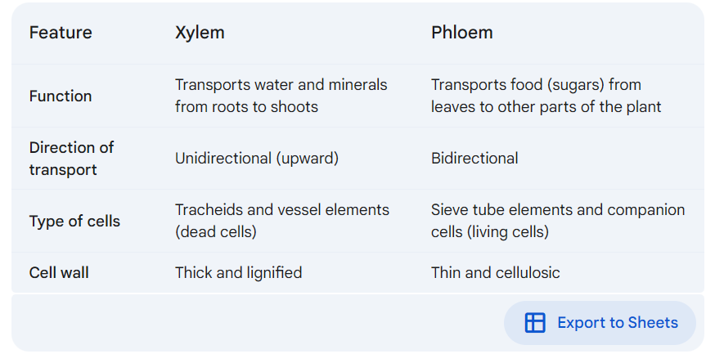
Q.12. Differentiate between: Xylem and Phloem functioning

Section c
.13. Draw neat labelled diagram: Aurelia
Unfortunately, I cannot draw diagrams directly here. However, I can describe the key features of an Aurelia diagram and provide resources where you can find detailed diagrams:
- Aurelia is a genus of jellyfish, commonly known as moon jellyfish.
- A typical diagram of Aurelia would show:
  - Bell-shaped body: This is the main body structure of the jellyfish.
  - Manubrium: A tube-like structure hanging down from the center of the bell.
  - Oral arms: Four or eight arms extending from the manubrium, used for capturing prey.
  - Tentacles: Long, thin structures around the edge of the bell, used for capturing prey and sensing the environment.
  - Radial canals: A network of canals within the bell, used for digestion and circulation.
  - Gastric pouches: Pouches located in the center of the bell, where digestion occurs.

Q.14. Distinguish between Mitosis and Meiosi
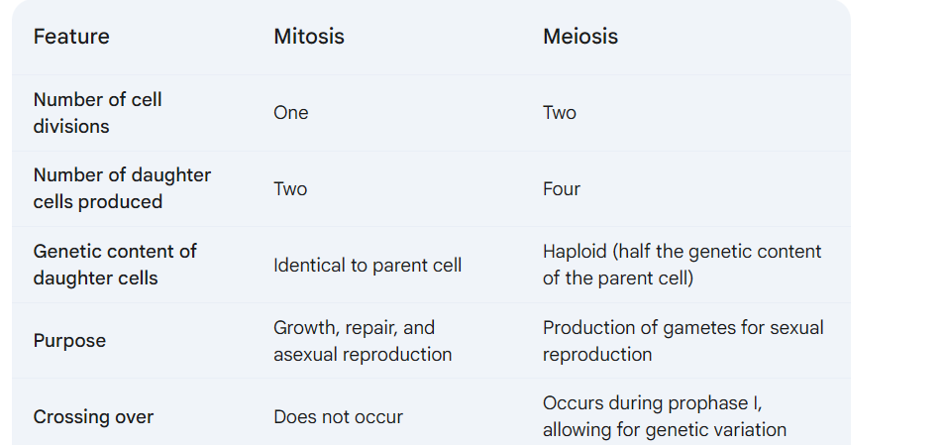
Q.15. Differentiate between Dicotyledonae and Monocotyledonae based on the following characters
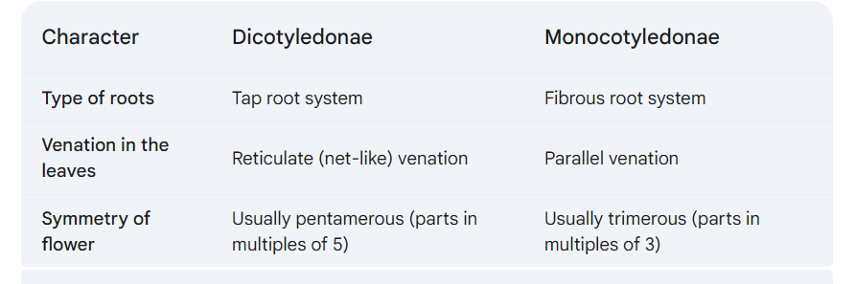
Q.4What are the salient features of Monera?
Monera is a kingdom that includes prokaryotic organisms, primarily bacteria. Key features of Monera include:
- Prokaryotic cells: Lack a nucleus and membrane-bound organelles.
- Unicellular: Single-celled organisms.
- Diverse habitats: Found in a wide range of environments, including extreme conditions.
- Reproduction: Asexual reproduction through binary fission.
- Nutrition: Diverse modes of nutrition, including autotrophic (photosynthesis) and heterotrophic (consuming other organisms).
- Cell wall: Composed of peptidoglycan.
- Genetic material: Single, circular chromosome.

Q.16. Complete chart and explain in your word
Types of Viruses
- Animal Viruses: These viruses infect animals, including humans. Examples include Influenza virus, HIV, and Rabies virus.
- Plant Viruses: These viruses infect plants. Examples include Tobacco mosaic virus and Potato virus X.
- Bacterial Viruses (Bacteriophages): These viruses infect bacteria. Examples include T4 bacteriophage and Lambda phage.
Q.17. What are types of plastids?
Plastids are double-membrane bound organelles found in plant cells. They are classified into three main types:
- Chloroplasts: These are green plastids that contain chlorophyll and are responsible for photosynthesis.
- Chromoplasts: These are plastids that contain pigments other than chlorophyll, such as carotenoids, which give fruits and flowers their colors.
- Leucoplasts: These are colorless plastids that store starch, lipids, or proteins.
Section - D
Q.18. Describe the types of lipids and mention their biological significance.
Lipids are a diverse group of organic compounds that are insoluble in water but soluble in organic solvents. They play various important biological roles. Some common types of lipids include:
- Triglycerides: These are the most common type of lipid, composed of three fatty acids attached to a glycerol molecule. They serve as energy storage molecules.
- Phospholipids: These lipids have a hydrophilic head and hydrophobic tails. They form the lipid bilayer of cell membranes.
- Steroids: These lipids have a characteristic four-ring structure. Cholesterol is an important steroid that is a component of cell membranes and a precursor for other steroid hormones.
Q.19. Why mitosis and meiosis-II are called as homotypic division?
Mitosis and meiosis-II are called homotypic divisions because they involve similar stages and processes. In both divisions, the chromosomes align at the metaphase plate, and sister chromatids separate during anaphase. However, the end result differs: mitosis produces two diploid daughter cells, while meiosis-II produces four haploid daughter cells.
Q.20. Write details about plant life cycle and alternation of generation.
The plant life cycle involves an alternation of generations between a diploid sporophyte generation and a haploid gametophyte generation.
- Sporophyte Generation: The sporophyte is the diploid phase of the plant life cycle. It produces haploid spores through meiosis.
- Gametophyte Generation: The spores germinate into haploid gametophytes. Gametophytes produce haploid gametes (sperm and egg) through mitosis.
- Fertilization: The fusion of sperm and egg results in a diploid zygote, which develops into a new sporophyte generation.
Q.21. Fern is a vascular plant. Yet it is not considered a Phanerogams. Why?
Phanerogams are plants that produce seeds. Ferns, while vascular plants, do not produce seeds. They reproduce through spores, which are microscopic reproductive structures that germinate into gametophytes. Therefore, ferns are classified as cryptogams, rather than phanerogams.

